Lesson 4 Demo 8: Create a Pod with sleep Argument

This section will guide you to:

* Create a pod with sleep argument

This lab has one sub-section, namely:

1. Creating a pod with sleep argument

**Note:** If you don’t have an existing Kubernetes cluster, refer to the Demo 1.1 of Lesson 1.

**Step 1:** Creating a pod with sleep argument

* Start the kubernetes cluster in the lab
* When you create a pod, you can define the command and arguments for the containers that run in the pod. In this exercise, you create a pod that runs one container. The configuration file for the pod defines a command and two arguments as shown below:

*cat > commands.yaml*

apiVersion: v1

kind: Pod

metadata:

name: command-demo

labels:

purpose: demonstrate-command

spec:

containers:

- name: command-demo-container

image: debian

command: ["printenv"]

args: ["HOSTNAME", "KUBERNETES_PORT"]

restartPolicy: OnFailure

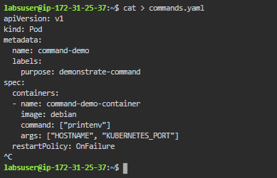

* Next, let’s create a pod based on the yaml configuration file using kubectl as shown below:

*kubectl apply -f commands.yaml*



* To see the output of the command that ran in the container, view the logs from the pod as shown below:

*kubectl logs command-demo*

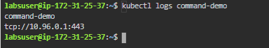

* In some cases, you need your command to run in a shell  
  **For example**: your command might consist of several commands piped together, or it might be a shell script. To run your command in a shell, wrap it like shown below, using sleep argument
* Delete the command-demo with the command:

*kubectl delete -f commands.yaml*



* Create a new yaml file with the command:

*cat > commands.yaml*

apiVersion: v1

kind: Pod

metadata:

name: command-demo

labels:

purpose: demonstrate-command

spec:

containers:

- name: command-demo-container

image: debian

command: ["/bin/sh"]

args: ["-c", "while true; do echo hello; sleep 10;done"]

restartPolicy: OnFailure

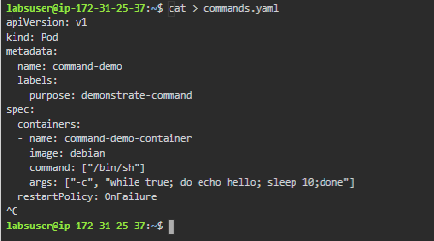

* Next, let’s create a pod based on the yaml configuration file using kubectl as shown below:

*kubectl apply -f commands.yaml*



* To see the output of the command that ran in the container, view the logs from the pod as shown below
* The output will be visible after a period mentioned in sleep args

*kubectl logs command-demo*

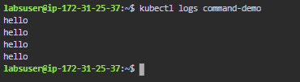

* Run *kubectl delete pods --all*to delete all pods